**Name : Nairaa Ehab**

**Section : 8**

Quiz 1 20/2/2020

1-

In the Hypothetical Machine the contents of memory was as shown. And PC contents is 300. Show the contents of memory and PC , AC , IR after execute three instructions (three fetch cycle and there execute cycle)

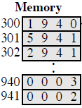

**Answer :**

**Load**

** PC : 300**

**AC : 0003**

**IR : 1940**

**Add**

** PC : 301**

**AC : 0005**

**IR : 5941**

**Store**

** PC : 302**

**AC : 0000**

**IR : 2941**

2-

* Show the contents of PC , AC and IR and memory after the execution of each instruction of the following program on the Hypothetical Machine:
* 300 LOAD 550
* 301 ADD 551
* 302 STORE 600
* Where the contents of memory at 550 is 3 and at 551 is 4.

**Answer :**

**Load**

**300 : 1550 PC : 300**

**301 : 5551 AC : 0003**

**302 : 2600 IR : 1550**

**550 : 0003**

**551 : 0004**

**600 : 0000**

**Add**

**300 : 1550 PC : 301**

**301 : 5551 AC : 0007**

**302 : 2600 IR : 5551**

**550 : 0003**

**551 : 0004**

**600 : 0000**

**Store**

**300 : 1550 PC : 302**

**301 : 5551 AC : 0000**

**302 : 2600 IR : 2600**

**550 : 0003**

**551 : 0004**

**600 : 0007**

* 3-
* The following figure provide the main characteristics of Hypothetical Machine.
* 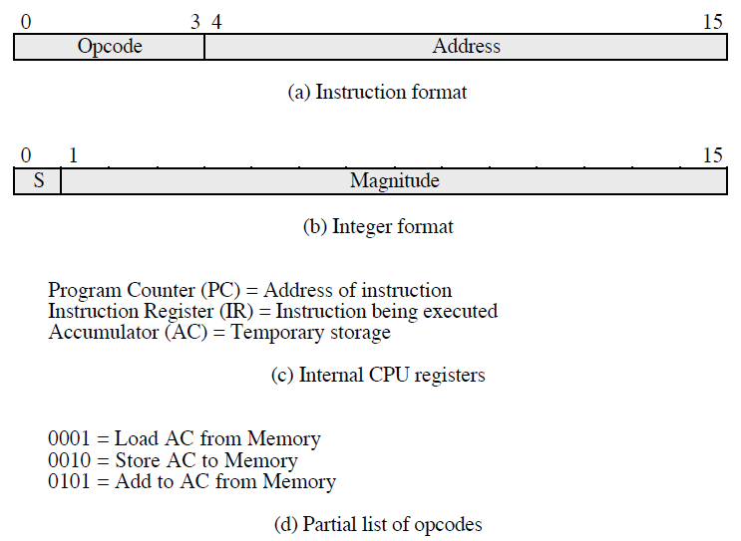

The hypothetical machine also has two I/O instructions:

0011 = load AC from I/O

0111 =store AC to I/O

In these case, the 12-bi address identifies a particular I/O device. Show the program execution for the following program:

1. Load AC from device 5.

2. Add contents of memory location 940.

3. Store AC to device 6.

Assume that the next value retrieved from device 5 is 3 and that location 940 contains a value of 2.

**Answer :**

**300 : 3005**

**301 : 5940**

**302 : 7006**

**Device 5 : 0003**

**940 : 2**

**Device 6 : 0005**